Wildlife Conservation Option

School of Environmental and Forest Sciences

University of Washington

Box 352100

Seattle, Washington 98195-2100

**SENIOR HONORS THESIS PROPOSAL**

**ESRM 494**

TO: Sarah J. Converse

TITLE OF PROPOSED PROJECT: Relationship between Scripps’s Murrelets (*Synthliboramphus scrippsi*) egg size and marine conditions at Santa Barbara Island, California, USA

STUDENT'S NAME: Marcela Todd Zaragoza

DATE: March 17, 2021

**Abstract**

Oceanic conditions are known to affect a variety of life history parameters in seabirds, but the degree to which egg size responds to environmental conditions has been investigated only rarely. The resources available to an avian embryo have the potential to influence survival of the embryo and of the chick post-hatching. I will investigate the effects of oceanographic conditions on Scripps's Murrelet (*Synthliboramphus scrippsi*) egg size at Santa Barbara Island, California, USA, from 2009-2017. Environmental covariates that characterize the marine environment at various spatial and temporal scales (e.g., sea surface temperature, the Pacific Decadal Oscillation index, and forage fish abundance) will be included in this analysis. Scripps's Murrelets lay eggs that are relatively large for their body size and must therefore gain substantial resources from their environmental surroundings to accomplish this. My goal with this research is to understand which factors, if any, are driving variance in egg size. I will model these relationships using linear mixed models that include environmental covariates and egg-laying order as fixed effects as well as random plot and observer effects. Egg measurement data are collected at Santa Barbara Island during nest monitoring. Given that collection of egg measurement data takes time and could disrupt breeding birds, a better understanding of the significance of these data for population analysis and conservation will inform future monitoring efforts.

**Introduction**

Seabirds have previously been identified as reliable indicators of marine ecosystem health (Mallory et al., 2010, Cairns, 1986; Velarde et al., 2019). Fluctuating marine conditions can impact the demography of seabirds due to their dependence on marine ecosystems for foraging. For example, Cassin’s Auklets (*Ptychoramphus aleuticus*) at Triangle Island (British Columbia, Canada), have shown reduced offspring survival and fledging mass in years of warm sea surface temperatures (SSTs) due to limited prey availability (Hipfner, 2008). Changes in marine conditions have also been linked to declines in growth rate and fledging success of Tufted Puffins (*Fratercula cirrhata*) off the coast of British Columbia (Gjerdrum, 2003) as well as changes in clutch size of Scripps’s Murrelets (*Synthliboramphus scrippsi)* off the coast of California, United States(Roth et al., 2005). Examining the relationship between marine conditions and direct reproductive parameters is a challenging task due to the varying scales at which these processes operate.

Interannual and interdecadal oceanographic variation also plays an important role in determining the egg size of some seabird species, though this relationship has been only rarely investigated. In general, egg size varies with the amount of energy invested in egg production, and the energy available to invest can be a function of environmental conditions (Williams, 2005). In Norway, Atlantic Puffin (*Fratercula arctica*) populations at two separate colonies (1980-2011) showed an annual decrease in population size and parallel decrease in egg volume (Barrett et al., 2012). Egg volune was modeled as a function of regional (e.g., winter North Atlantic Oscillation) and local (e.g., April SST) oceanographic conditions, and results indicated that low food availability prior to egg-laying leads to decreases in egg size. Hipfner (2012) found that egg size increased with SST for Glaucous-winged Gulls (*Larus glaucescen*s), but the effect was small and limited to one and three-egg clutches.

Scripps’s Murrelets (hereafter murrelets) are a small seabird in the Alcidae family that breeds along the west coast of California, United States and Baja California, Mexico. Investigation of the relationships between marine conditions and murrelet breeding success have been limited to an analysis of the effects of ocean productivity on murrelet clutch initiation timing and size (Roth et al., 2005). That analysis revealed that higher ocean productivity leads to earlier clutch initiation dates and higher clutch sizes. However, there has not been any analysis of the relationship between oceanographic conditions and egg size. Murrelet eggs represent, on average, 23.7% of the female body mass, making them one of the largest eggs relative to body weight in the Alcidae family (Sealy, 1975). Murrelet chicks are precocial, departing the nest ~1-2 days after hatching. This precociality requires large eggs and females must forage several days before laying each egg in order to obtain the necessary nutrients (Murray et al., 1983).

The largest US-based breeding colony of murrelets occurs at Santa Barbara Island (SBI), the smallest island in Channel Islands National Park, California (Carter et al., 1992; Figure 1). SBI is located in the Southern California Bight, which is highly dynamic and experiences interannual fluctuations in ocean productivity (Checkley and Barth, 2009) and therefore provides an opportunity to investigate the ways in which these factors may influence murrelet egg size. By looking at regional environmental patterns in the Northeast Pacific Ocean (Pacific Decadal Oscillation and El Niño Southern Oscillation) and more local patterns in the Channel Islands (SST and forage fish populations), I will determine whether environmental factors are important for predicting murrelet egg size.

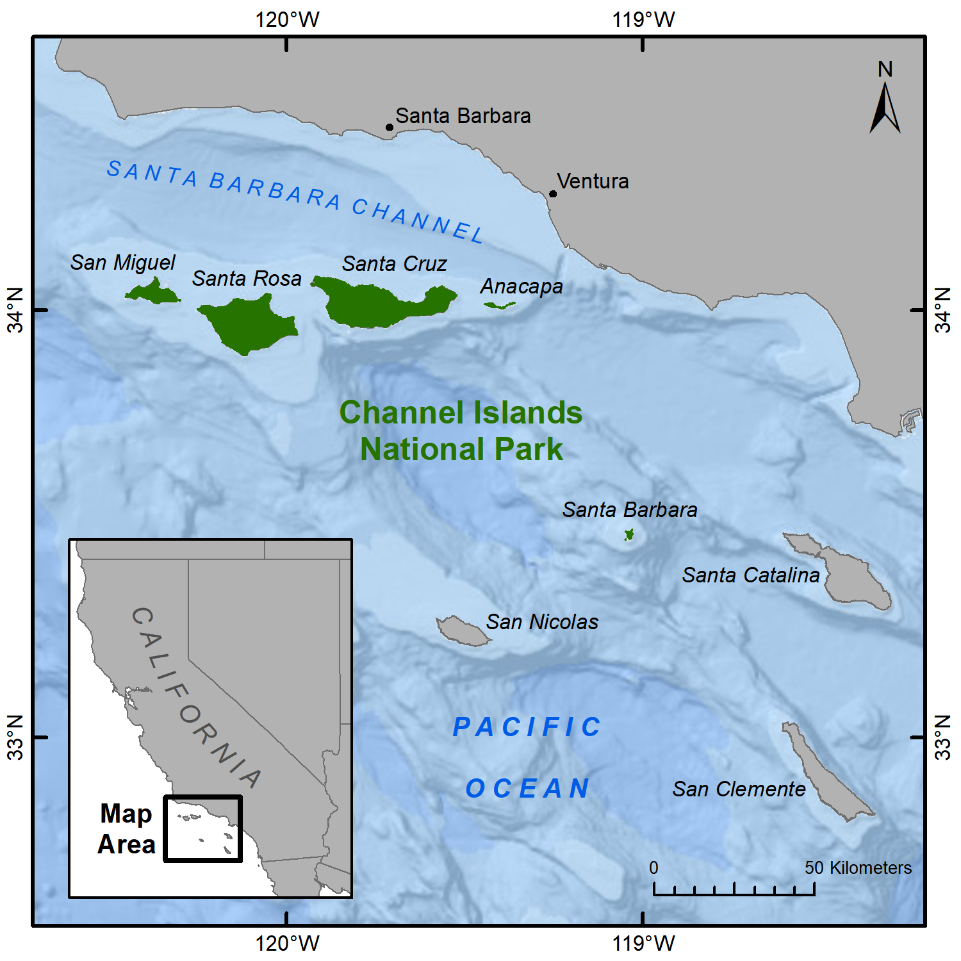

**Figure 1**. The Channel Islands, California, USA. Credit: Amelia DuVall.

**Research Objectives**

I have four specific research objectives, including:

1. Examine the relationship between murrelet egg size and environmental conditions at Santa Barbara Island.
2. Investigate inherent differences in the size of the first and second egg laid in a clutch.
3. Determine whether egg size measurements vary substantially due to plot (indicating small-scale geographic variation) or observer (indicating observation error in measurements).
4. Evaluate the value of collecting egg size information in Channel Islands National Park’s murrelet monitoring protocol.

Through this analysis, information will be obtained about the relationships between marine conditions and murrelet egg size at SBI. Given the large relative size of eggs produced by murrelets, necessary to support precociality, investment in egg production requires a large amount of energy. Given that murrelets must rely on their dynamic marine environment to gain those resources, fluctuations in the marine conditions will likely be reflected in fluctuations in egg size. I hypothesize that environmental conditions that lead to higher ocean productivity will result in larger egg sizes. Specifically, I hypothesize that cool, nutrient-rich marine conditions will lead to higher ocean productivity that provides optimal foraging conditions for murrelets, and thus larger egg sizes. This includes negative Pacific Decadal Oscillation index values, negative El Niño/Southern Oscillation values, high values of the Biologically Effective Upwelling Transport Index, high larval anchovy catch-per-unit-effort values, and low sea surface temperatures. I also hypothesize there will be inherent differences between the first and second egg laid and that both plot will have an influence on egg size and observer will have an influence on egg measurements. Lastly, I predict this research will reveal new information about the importance of egg monitoring at SBI, which will provide valuable information to prioritize murrelet population monitoring activities in the future.

**Proposed Methods**

*Data collection*

Santa Barbara Island (33.4756° N, 119.0373° W) is the smallest (2.6 $km^{2}$) of the eight California Channel Islands and it hosts the largest breeding colony for murrelets in this region. The data used for this analysis were part of a larger project funded primarily by the Montrose Settlements Restoration Program at Channel Islands National Park. Data were collected from 2009-2017 during the breeding season, which lasts from March to June and peaks in April (Murray et al., 1983). In order to obtain egg measurements, eggs were first deemed accessible if they were within safe reach of the observer and no adult bird was present at the site. Eggs were then removed from the nest, marked with a permanent marker, and measured using Vernier calipers. Egg length and width (at the widest point) were obtained to the nearest millimeter. After measurements were obtained, the egg was returned to its original position and orientation. Eggs were only measured once at each nest. Egg order was recorded as either “Yes'' or “No” if it could be distinguished whether one egg was laid before the other. If both eggs were present upon first encounter, egg order was indeterminable, but if the nest was encountered between the laying of the first and second eggs, eggs were labeled with a marker to indicate egg order. The plots included in this analysis are: Arch Point North Cliffs (APNC), Bunkhouse (BH), Boxthorn (BT), Cat Canyon (CC), Dock (DO), Elephant Seal Cove (ESC), Landing Cove (LC), and West Cliffs (WC). If available, I will also use older egg measurement records from Santa Barbara Island; the availability of these records is currently being determined.

*Covariates*

I will fit a suite of covariates to investigate the effect of environmental conditions on egg size. Environmental covariates that characterize large-scale oceanographic condition include the Pacific Decadal Oscillation (PDO) index, a measure of temperature anomalies in the North Pacific; the El Niño/Southern Oscillation (ENSO) index, a measure of sea surface temperature and air pressure fluctuations in the equatorial Pacific Ocean; and the Biologically Effective Upwelling Transport Index (BEUTI), which estimates vertical nitrate flux near the U.S. west coast. For a region-wide covariate, I will use larval anchovy catch-per-unit-effort sampling data sampled in the area from San Francisco Bay to San Diego by the California Cooperative Oceanic Fisheries Investigations (CalCOFI). For a local covariate, I will use mean sea surface temperature collected by National Oceanic and Atmospheric Administration's buoy station 46025 (33.758° N 119.044° W) during the pre-breeding/early breeding season (February-April). All covariates will be standardized by subtracting the mean and dividing by the standard deviation of the data. Due to the likelihood of relationships between covariates (e.g., fish abundance is often related to upwelling), covariate collinearity will be evaluated to avoid fitting models with multiple highly collinear covariates.

*Model Formulation*

I will develop a set of models to investigate the relationship between environmental covariates and egg size. Egg size will be modeled using a linear mixed model with normal errors and multiple random processes. By using random effects, I will account for the variability that may be associated with the measurement techniques of different observers, and the location, accessibility, and microclimate of different plots. Additionally, egg order will be modeled as a fixed effect to try to understand whether egg size differs by egg order. Using this set of models, model selection will be performed via Akaike’s Information Criterion (AIC) to identify fixed effects and likelihood ratio tests to identify random effects.



$$y_{i}= β_{0} + β_{1}x_{1} + ... + β_{k}x_{k}+ β_{eggorder}x_{eggorder} + α_{p }+ α_{o }+ α_{t }+ ε_{i}$$

$α_{p}$ ~ N($0, {σ^{2}}_{α_{p}}$)

$α_{o }$ ~ N($0, {σ^{2}}_{α_{o}}$)

$α_{t}$ ~ N($0, {σ^{2}}_{α_{t}}$)

$ϵ_{i}$ ~ N($0, σ^{2}$)

where $y_{i}$ is egg size *i*

$β_{0}$ is the intercept

*k* is the number of predictors in a given model

$β_{k}$ are model coefficients for covariates $x_{k}$ (including egg order)

$α_{p}$ is the random effect for plot, with variance ${σ^{2}}_{α_{p}}$

$α_{o}$ is the random effect for observer, with variance ${σ^{2}}_{α_{o}}$

$α_{t}$ is the random effect for year, with variance ${σ^{2}}_{α_{t}}$

$ϵ_{i}$ is the error for egg *i*, with model variance $σ^{2}$

*Preliminary Analysis*

Egg size is the product of egg length and egg width for each egg. There are some values that appear to be outliers, possibly due to transcription errors, which will have to be further examined to determine whether they should be omitted from the analysis (Figures 2 and 3). There are 767 values for egg 1 size and 249 values for egg 2 size (*n* = 1016 total samples). The plots with the most observations are APNC (139), LC (298), and CC (305) and there are a total of 27 different observers. Based on the boxplot of egg 1 and 2 values, there does not appear to be much variation between years (Figure 4). Mean egg 1 size is 1891.134 and mean egg 2 size is 1920.885.

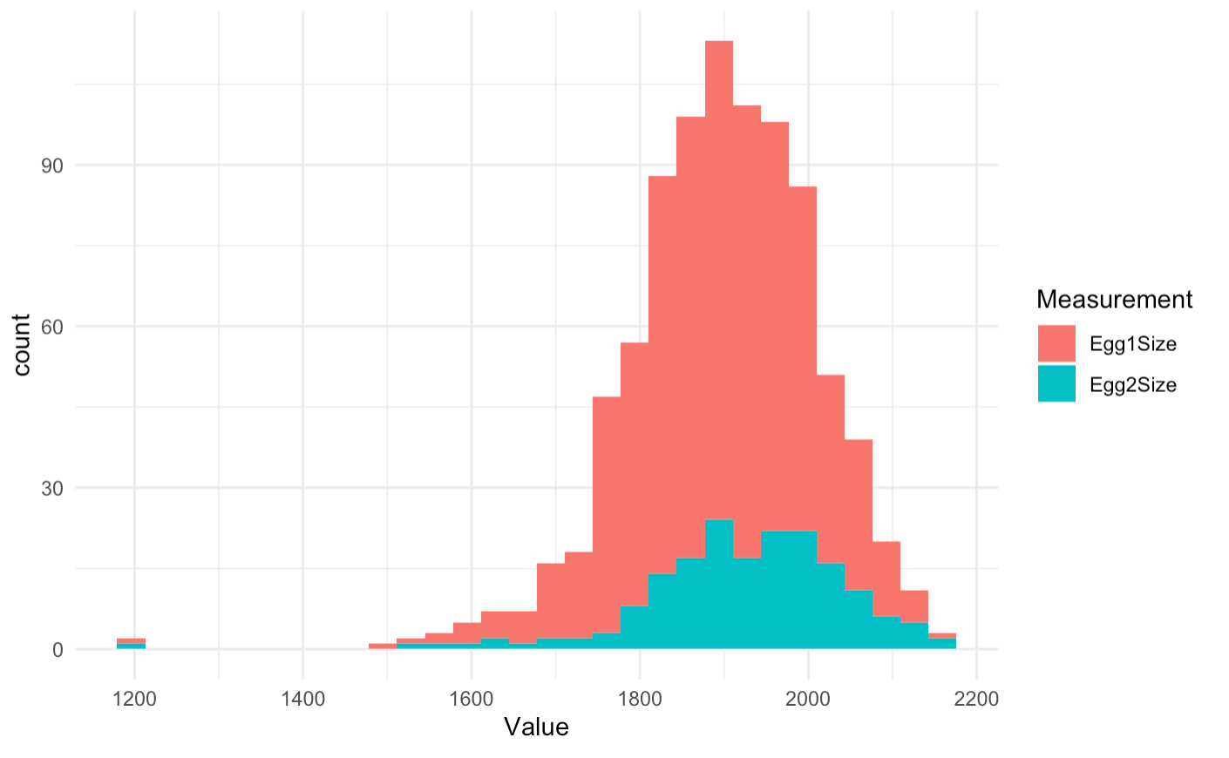

**Figure 2**. Distribution of the count of egg size values for egg 1 and egg 2.

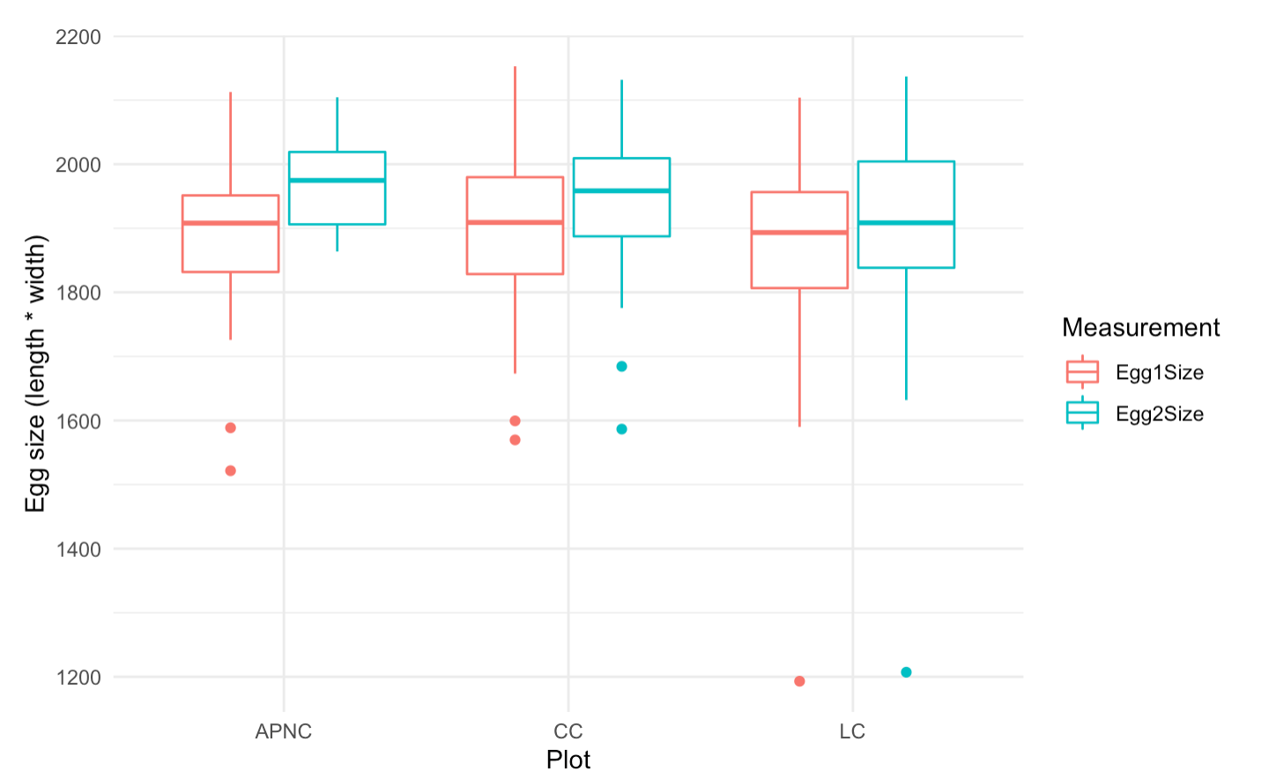

**Figure 3**. Egg size differences between the plots with the most records (APNC, CC, and LC).

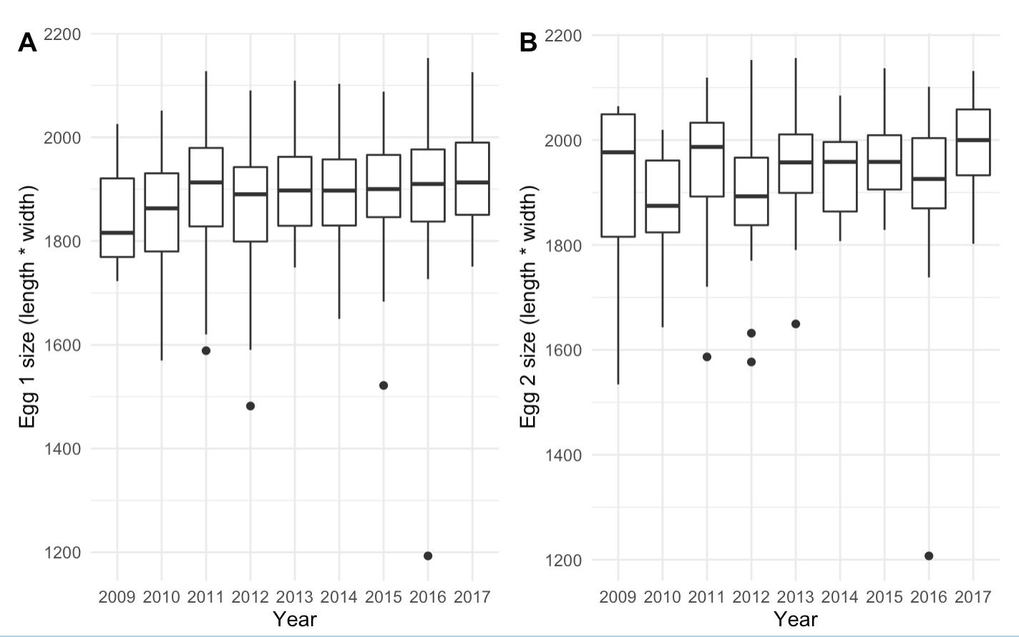

**Figure 4**. (A) Egg 1 size values from 2009-2017. (B) Egg 2 size values.

**Anticipated Outcomes**

My results on the effect of environmental fluctuations on egg size will help to predict how murrelet populations may respond to changing oceanic conditions, particularly if embryo survival or post-hatching performance of chicks can be linked to egg size. My results on the effect of egg order on egg size will provide a clearer understanding of how energy is allocated across multiple eggs; it appears this energy allocation is not equal given that second eggs appear to be larger than first eggs (Murray et al., 1983; preliminary results). My analysis of the effects of plot on egg size will provide insight into possible plot differences, which could be attributed to differences in foraging areas for birds in different plots, or potentially genetic differences. Given the natal site fidelity of many seabirds, genetic isolation may quickly develop over relatively small spatial scales. Alternatively, some differences in egg size by plot could be attributable to observers. For example, APNC, one of the three plots with the most data points, is hard to monitor and requires skilled observers (Harvey et al., 2014) which suggests that observer effort is not allocated equally across plots. Thus, I will also evaluate the degree to which observers themselves influence egg measurements due to slightly different egg measurement practices. If observer effects appear to be important, this would suggest that further training is warranted to better standardize egg measurement if it is to continue as part of the monitoring protocol. Lastly, although there have been efforts to collect egg measurement data at SBI for many years, no analysis of those measurements has been conducted. This research will provide an initial step towards understanding the importance of collecting these monitoring data. This analysis is important because egg size monitoring requires significant time and effort and could potentially be disruptive to murrelet breeding through the direct handling of eggs.

**Research Timetable**

|  |  |
| --- | --- |
| **Tasks** | **Time allocation** |
| Data collection | Completed |
| Data analysis | 2-3 weeks at the beginning of Spring Quarter (April) |
| Thesis   * Initial draft will be turned in for revision to AJD * Revised draft to SJC | 3 weeks   * Work on draft: Weeks 4 through 7 * Turn in draft by week 7 * Revisions returned by week 8-9 * Make edits and turn in at the end of the quarter |
| Poster presentation | 2 weeks   * Presentation week 9/10 |

**Literature Cited**

Barrett, R., Nilsen, E., & Anker-Nilssen, T. (2012). Long-term decline in egg size of Atlantic puffins Fratercula arctica is related to changes in forage fish stocks and climate conditions. *Marine Ecology Progress Series*, *457*, 1–10.<https://doi.org/10.3354/meps09813>

Bennett, J. L., Jamieson, E. G., Ronconi, R. A., & Wong, S. N. P. (2017). Variability in egg size and population declines of Herring Gulls in relation to fisheries and climate conditions. *Avian Conservation and Ecology*, *12*(2), art16.<https://doi.org/10.5751/ACE-01118-120216>

Burkett, E.E., N.A. Rojek, A.E. Henry, M.J. Fluharty, L. Comrack, P.R. Kelly, A.C. Mahaney, and K.M. Fien. (2003). Report to the California Fish and Game Commission: Status Review of Xantus’s Murrelet (Synthliboramphus hypoleucus) in California. Calif. Dept. of Fish and Game, Habitat Conservation Planning Branch Status Report 2003-03. 96 pp. + appendices.

Checkley, D. M., & Barth, J. A. (2009). Patterns and processes in the California Current System. *Progress in Oceanography*, *83*(1), 49–64.<https://doi.org/10.1016/j.pocean.2009.07.028>

Gjerdrum, C., Vallée, A. M. J., Clair, C. C. S., Bertram, D. F., Ryder, J. L., & Blackburn, G. S. (2003). Tufted puffin reproduction reveals ocean climate variability. Proceedings of the National Academy of Sciences, 100(16), 9377–9382. https://doi.org/10.1073/pnas.1133383100

Harvey, A.L., J.A. Howard, R.R. Robison, D.M. Mazurkiewicz, M.E. Jacques, S.A. Auer, C.A. Carter, K.W. Barnes, A.A. Yamagiwa and S.J. Kim. (2014). Scripps’s Murrelet, Cassin’s Auklet, and Ashy Storm-Petrel reproductive monitoring and restoration activities on Santa Barbara Island, California in 2012. Unpublished report, California Institute of Environmental Studies. 38 pages.

Hipfner, J. (2008). Matches and mismatches: Ocean climate, prey phenology and breeding success in a zooplanktivorous seabird. *Marine Ecology Progress Series*, *368*, 295–304.<https://doi.org/10.3354/meps07603>

Hipfner, J. M. (2012). Effects of Sea-surface Temperature on Egg Size and Clutch Size in the Glaucous-winged Gull. Waterbirds, 35(3), 430–436. https://doi.org/10.1675/063.035.0307

Mallory, M. L., Robinson, S. A., Hebert, C. E., & Forbes, M. R. (2010). Seabirds as indicators of aquatic ecosystem conditions: A case for gathering multiple proxies of seabird health. *Marine Pollution Bulletin*, *60*(1), 7–12.<https://doi.org/10.1016/j.marpolbul.2009.08.024>

Murray, K., Winnett-Murray, K., & Hunt, G. (1980). Egg Neglect in Xantus' Murrelet. Proceedings of the Colonial Waterbird Group, 3, 186-195. Retrieved March 17, 2021, from http://www.jstor.org/stable/4626713

Murray, K. G., Winnett-Murray, K., Eppley, Z. A., Hunt, G. L., & Schwartz, D. B. (1983). Breeding Biology of the Xantus’ Murrelet. The Condor, 85(1), 12–21. https://doi.org/10.2307/1367880

Piatt, I., & Sydeman, W. (2007). Seabirds as indicators of marine ecosystems. Marine Ecology Progress Series, 352, 199–204. https://doi.org/10.3354/meps07070

Piatt, J. F., Harding, A. M. A., Shultz, M., Speckman, S. G., van Pelt, T. I., Drew, G. S., & Kettle, A. B. (2007). Seabirds as indicators of marine food supplies: Cairns revisited. Marine Ecology Progress Series, 352, 221–234. https://doi.org/10.3354/meps07078

Roth, J. E., Sydeman, W. J., & Martin, P. L. (2005). Xantus's Murrelet breeding relative to prey abundance and oceanographic conditions in the Southern California Bight. https://www.marineornithology.org/PDF/33_2/33_2_115-121.pdf

Sealy, S. G. (1975). Egg Size of Murrelets. *The Condor*, *77*(4), 500.<https://doi.org/10.2307/1366104>

Sydeman, W., Thompson, S., & Kitaysky, A. (2012). Seabirds and climate change: Roadmap for the future. *Marine Ecology Progress Series*, *454*, 107–117.<https://doi.org/10.3354/meps09806>

Williams, Tony D. (2005). Mechanisms Underlying the Costs of Egg Production. *BioScience*, *55*(1), 39. [https://doi.org/10.1641/0006-3568(2005)055[0039:MUTCOE]2.0.CO;2](https://doi.org/10.1641/0006-3568(2005)055%5b0039:MUTCOE%5d2.0.CO;2)